GS-Impute 1.0 User Guide
System Requirements:
PyTorch installation (mandatory)
GPU-enabled PyTorch version (recommended)
Here are the install commands of PyTorch. Scroll down for the step-by-step instructions.
1.1 Step-by-step instructions of installing PyTorch
1. Install Miniconda
Miniconda is the recommended approach for installing PyTorch with GPU support. It creates a separate environment to avoid changing any installed software in your system. This is also the easiest way to install the required software especially for the GPU setup. Download the Miniconda Windows Installer (https://repo.anaconda.com/miniconda/Miniconda3-latest-Windows-x86_64.exe). Double-click the downloaded file and follow the instructions on the screen.
2. Create a Conda environment
Create a new Conda environment named pytorch (other names are also acceptable) with the following commands in a terminal window (taking python 3.9 as an example).
conda create --name pytorch python=3.9
You can deactivate and activate it with the following commands.
conda deactivate
conda activate pytorch
Make sure it is activated for the rest of the installation.
3．GPU setup
You can skip this section if you only run PyTorch on CPU.
First install NVIDIA GPU driver if you have not.
Then install CUDA and cuDNN (taking NVIDIA RTX 4090 as an example) in a terminal window.
conda install -c conda-forge cudatoolkit=11.2 cudnn=8.1.0
4．Install PyTorch
PyTorch requires a recent version of pip, so upgrade your pip installation to be sure you are running the latest version.
Then, install PyTorch with the following command.
pip3 install torch torchvision torchaudio --index-url https://download.pytorch.org/whl/cu118
5. Verify your installation
To ensure that PyTorch was installed correctly, we can verify the installation by running sample PyTorch code. Here we will construct a randomly initialized tensor. If a tensor is returned, you've installed PyTorch successfully.
import torch
x = torch.rand(5, 3)
print(x)
To check if your GPU driver and CUDA are enabled and accessible by PyTorch, run the following commands to return whether or not the CUDA driver is enabled.
import torch
torch.cuda.is_available()
1.2 Install GS-Impute
You should download and unzip the GS-Impute 1.0 package. If under the Windows operating system, open a terminal window and enter the extracted folder (taking “D:\GSImpute1.0_Windows” as an example). Then activate your Conda environment that has already installed PyTorch, and install GS-Impute with the following commands.
D:
cd GSImpute1.0_Windows
conda activate pytorch
python install.py
1.3 Usage
1.3.1 For the Windows operating system
In a Windows operating system, a typical command for running GS-Impute is as follows:
gsi
Once you execute the command above in a terminal window, general imputation screen will be opened by default. The software interface and input/output format examples are shown in Fig. 1.
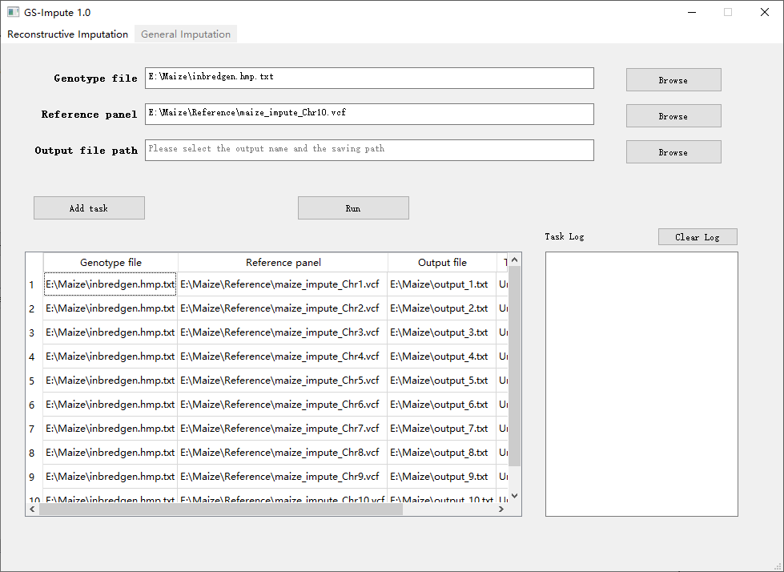

Fig. 1 | Software interface on Windows system and input/output format examples of GS-Impute 1.0 for general imputation. a, The user interface of GS-Impute 1.0 for general imputation on Windows system. b, The format example of the genotype file input for general imputation. c, The format example of the reference panel input for general imputation. e, The format example of the output file for general imputation.
You can click the “Browse” button on the right side to select the genotype file, the reference panel and the path of output file.
Once you have selected all the files, you can click the “Add task” button to add general imputation tasks to the task list (Fig. 2).

Fig. 2 | Software interface of GS-Impute 1.0 with general imputation tasks added
If all tasks have been added, you can click the “Run” button to execute the tasks. GS-Impute will execute tasks in the order of the task list.
During the task execution process, you can see the task log on the right. It contains the details and progress of the task execution.
You can also click the “Reconstructive Imputation” button to perform your reconstructive imputation (Fig. 3).
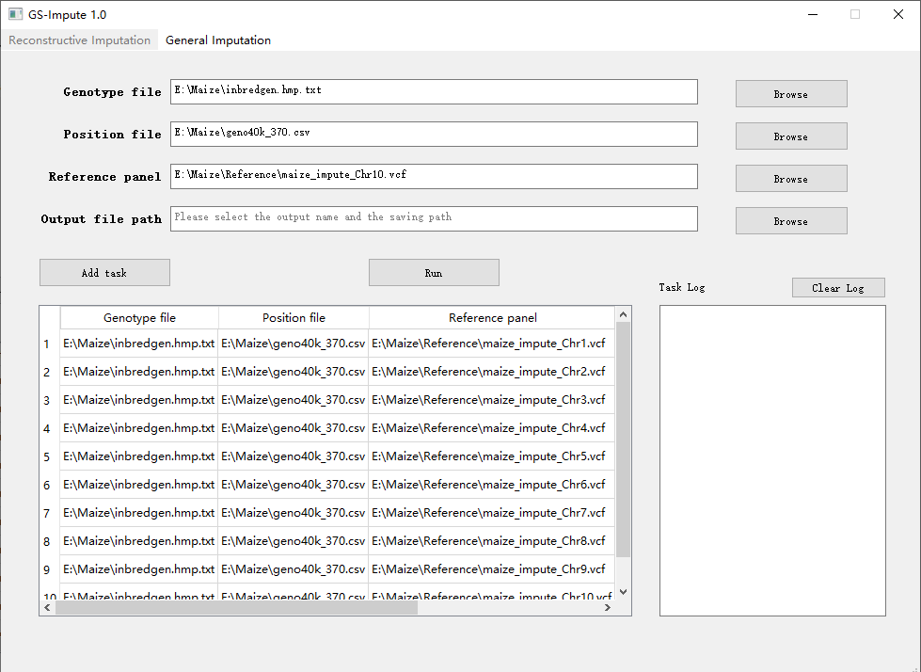

Fig. 3 | Software interface on Windows system and input/output format examples of GS-Impute 1.0 for reconstructive imputation. a, The user interface of GS-Impute 1.0 for reconstructive imputation on Windows system. b, The format example of the genotype file input for reconstructive imputation. c, The format example of the position file input for reconstructive imputation. d, The format example of the reference panel input for reconstructive imputation. e, The format example of the output file for reconstructive imputation. The genotype values of 1 and 3 represent homozygous variants with two reference alleles and two alternate alleles, respectively. The genotype value of 2 represents a heterozygous variant that has one copy of the reference allele and one copy of the alternate allele.
The reconstructive imputation requires a position file. You can select the position file by clicking the “Browse” button. The other usage process is the same as the general imputation.
Once you have selected all the files, you can click the “Add task” button to add reconstruction imputation tasks to the task list (Fig. 4).

Fig. 4 | Software interface of GS-Impute 1.0 with reconstructive imputation tasks added
1.3.2 For the Linux operating system
A typical GS-Impute command for the general imputation is as follows:
gsi -i -geno unimputedGenoFile.vcf -panel maize_Chr1.vcf
Or
gsi -i -geno unimputedGenoFile.csv -panel maize_Chr1.vcf
A typical GS-Impute command for the reconstructive imputation is as follows:
gsi -r -geno unimputed_geno_file.vcf -pos genofile.vcf -panel maize_Chr1.vcf
Or
gsi -r -geno unimputed_geno_file.csv -pos genofile.vcf -panel maize_Chr1.vcf
Or
gsi -r -geno unimputed_geno_file.vcf -pos chrom_position_file.csv -panel maize_Chr1.vcf
Or
gsi -r -geno unimputed_geno_file.csv -pos chrom_position_file.csv -panel maize_Chr1.vcf

